NAME………………………………………………………………… ………………………..

**KAMULI GIRLS COLLEGE**

**Uganda Certificate of lower secondary Education- 2023**

**S2 PHYSICS**

**535/1**

**Paper1**

**TIME: 2 hours**

**INSTRUCTIONS**

* Attempt **ALL** questions in section A & B
* Where necessary, consider the following:
* acceleration due to gravity = 10𝑚𝑠-2
* Density of water = 1000kgm-3
* Density of mercury = 13600kgm-3

**SECTION A**

**Write your answers in space provided**

1. One of the exciting songs that was sung by a class of little kids had a rhythm of **power**……, **power**…………..., and the response was **super power**………., **super**

**powe**r…………, They had not yet known that the term exists in Physics at high

school.

(a) Help the kids understand the term in their song, by definition.

(01 mark)

…………………………………………………………………………………………………………………………………………………………………………………………………………

(b) Write down the S.I unit of the quantity in the song. (01 mark)

………………………………………………………………………………………

(c) If the kids sing for 20 minutes by applying a total force of 500N on their

Mouths while moving in a town of distance 3 m, calculate the power developed. (02 marks )

……………………………………………………………………………………………………………………………………………………………………………………………………………………………………………………………………………………………………………………………………………………………………………………………………………………………

1. A day started with sun rays radiating energy to the earth’s surface.

(a). Identify the form of energy the earth receives. (01 mark)

………………………………………………………………………………………….

(b). identify any three forms of energy apart from the one above. (03 marks)

………………………………………………………………………………………………………

………………………………………………………………………………………………………………………………………………………………………………………………………….

1. A single force which produces the same effect on the body as a number of forces

acting on the same body is known as *………………………………………...* And

Cohesive and adhesive forces are inter – molecular forces which hold molecules of the

*………………………………....* and *…………………….…………*respectively together.

An insecticide placed in one corner of the house kills a mosquito resting on the

Sealing due to *…………………………………………*and putting a hard polythene under in the foundation of a building stops *……………………………………* (05 marks)

1. . Two men James and Peter were tasked to transfer bags of cement. Peter lifted **2** bags each weighing 50 kg and carried them through a distance of 4 meters. James carried**1** bag from the ground floor to the first floor using 150 stairs of height 0.02metreseach**.**

a) By calculation, of the two men who did more work? ( 03 marks )

*…………………………………………………………………………………………………*

*…………………………………………………………………………………………………*

*…………………………………………………………………………………………………*

*…………………………………………………………………………………………………*

b) If peter did his work in 3 minutes, and James in 1 minute. Who did work with?

more power. Show working.(02 marks)

*…………………………………………………………………………………………………*

*…………………………………………………………………………………………………*

*…………………………………………………………………………………………………*

*………………………………………………………………………………………………………*

c) Advise peter and James separately on how they can simply their work. Use the knowledge of machines. Clearly tell them the best machine each can use to have

their work done using the least possible energy. (*03 marks)*

………………………………………………………………………………………

………………………………………………………………………………………

………………………………………………………………………………………

………………………………………………………………………………………….

d) Help them know how they can separately improve on the efficiency of the machines chosen in order to further use less effort. (02 marks )

………………………………………………………………………………………………………………………………………………………………………………………………………………………………………………………………………………………………………………………………………………………………………………………………………..

1. a) with help of ray diagrams distinguish between the Regular and irregular reflection of light ( 02 marks )

……………………………………………………………………………………………………………………………………………………………………………………………………………

……………………………………………………………………………………………………………………………………………………………………………………………………………..

………………………………………………………………………………………………………

b) Peter moved out of the house early in the morning and he saw his picture on the ground moving along with him. He attributed this to witchcraft. As a physics learner explain to him what was the picture. (02 marks)

………………………………………………………………………………………………………………………………………………………………………………………………………………

………………………………………………………………………………………………………

1. (a) Peter had an experience of using a bore hole. When he held the handle

at its extreme end, water came out with ease and when Nakku held the handle

near the turning point, she failed to bring out water.

(i) Write down the term that summarizes the above experience. (01 mark).

………………………………………………………………………………

(ii) Identify the factors affecting the term in (a)(i) above. (02 marks)

…………………………………………………………………………………………………

………………………………………..................................................................................

(b). State the principle of moments. (01 mark)

1. Two students were provided with pendulum bob, a meter rule, a weighing scale, tape measure, a vernier caliper and a micrometer screw gauge.

(i) Identify the most suitable instrument for measuring the thickness of iron sheets. (1 mark)

……………………………………………………………………………

(ii) State any two examples of the materials that can be measured using a

vernier caliper. (02 marks)

……………………………………………………………………………………………………

……………………………………………………………………………………………………

(iii) Identify any source of error while using the meter rule in measurement.(01 mark)

………………………………………………………………………………………………………

**SECTION B**

**Write your answers on the answer sheet provided.**

1. a)Study the figure below, and use the ruler to measure the dimensions of the

rectangular wooden box provided.

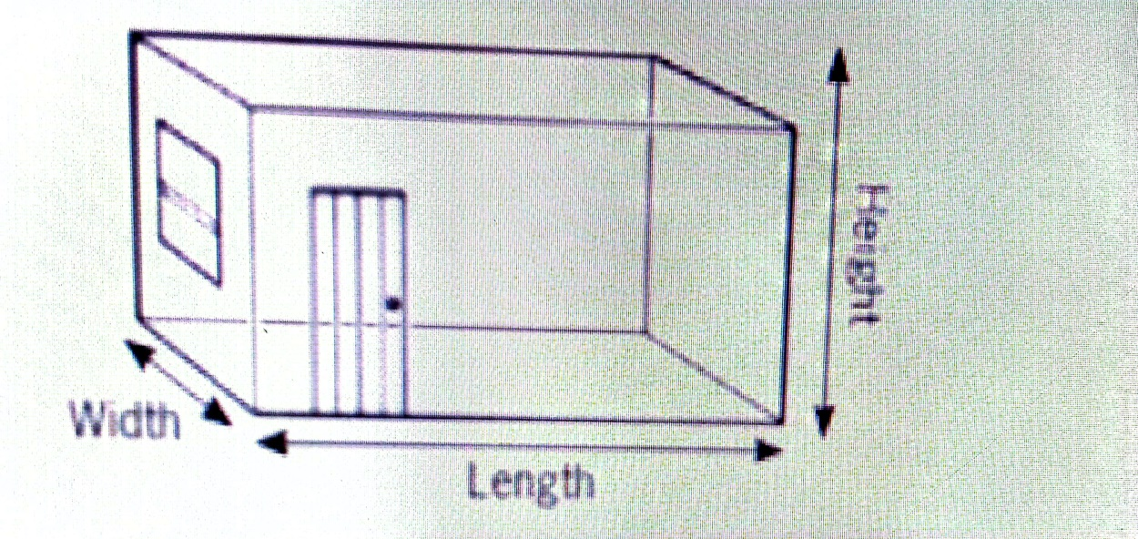

(i) Width. (01 mark)

(ii) Length. (01 mark)

(iii) Height. (01 mark)

(b). (i) determine the volume of the wooden box. (03 marks)

(ii). Write the answer in (b)(i) in scientific form. (01 mark)

(c). You have been selected by your teacher to settle an argument that broke out between S.1 Physics students about classification of **mass** and **weight** as scalar and vector quantities respectively. Help them to distinguish between the two terms, by giving;

(i) clear definitions of scalar and vector quantities. (02 marks)

(ii) Any other two examples of each quantity mentioned above (02 marks)

(d). Define the term force and state its S.I unit. (02 marks)

1. What is a lever as applied to simple machines (01mark)

(ii). Identify the classes of lever giving any two application on each. (06marks)

(b). A loaded wheelbarrow weighing **800 N** is pushed up an inclined plane by a force of **150N** parallel to the plane, if the plane rises **50 cm** for every **400 cm** length of the plane as shown below.

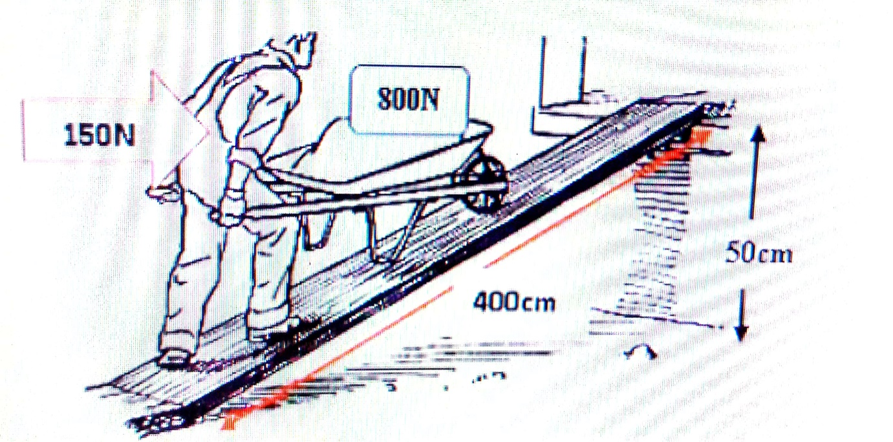

Find the **velocity ratio**, **mechanical advantage.** (4marks)

(C). The effort required to raise a load of **100N** is **40N** as shown below

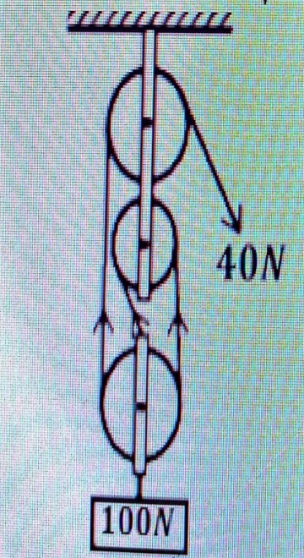

Calculate; (i) Mechanical advantage (2marks)

(ii) Efficiency (2marks)

(iii) Name two areas where pulleys are

commonly applied in real life. (2marks)

(d). A man carries a bag of cement of mass 50kg from the ground floor to the first floor using stairs of height 0.01m each as shown in the diagram below

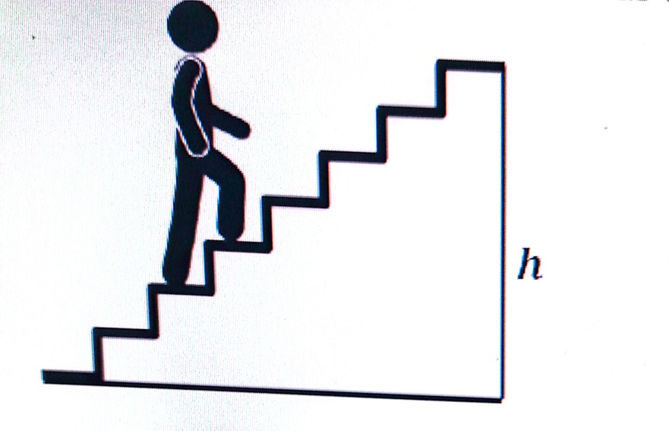

Determine the work done by this man to move a bag of cement from the ground floor to the first floor. (03marks)

**END**